By line - example: By Andrea Thomas

Start Article

Continue article

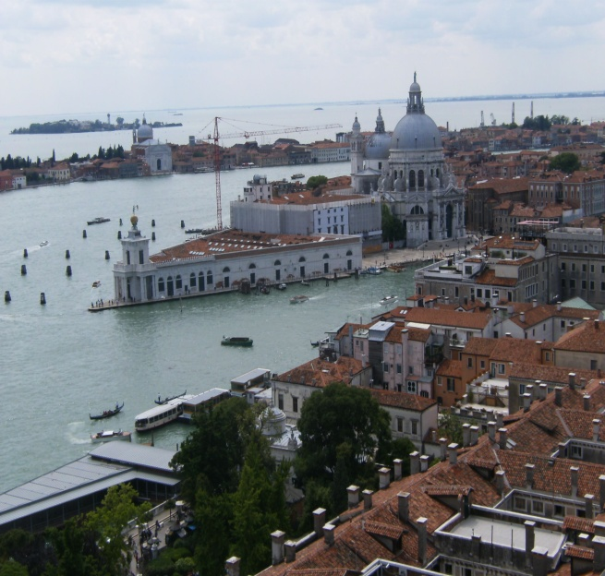

Caption – example: Venice, Italy in May 2010